Supplementary Material

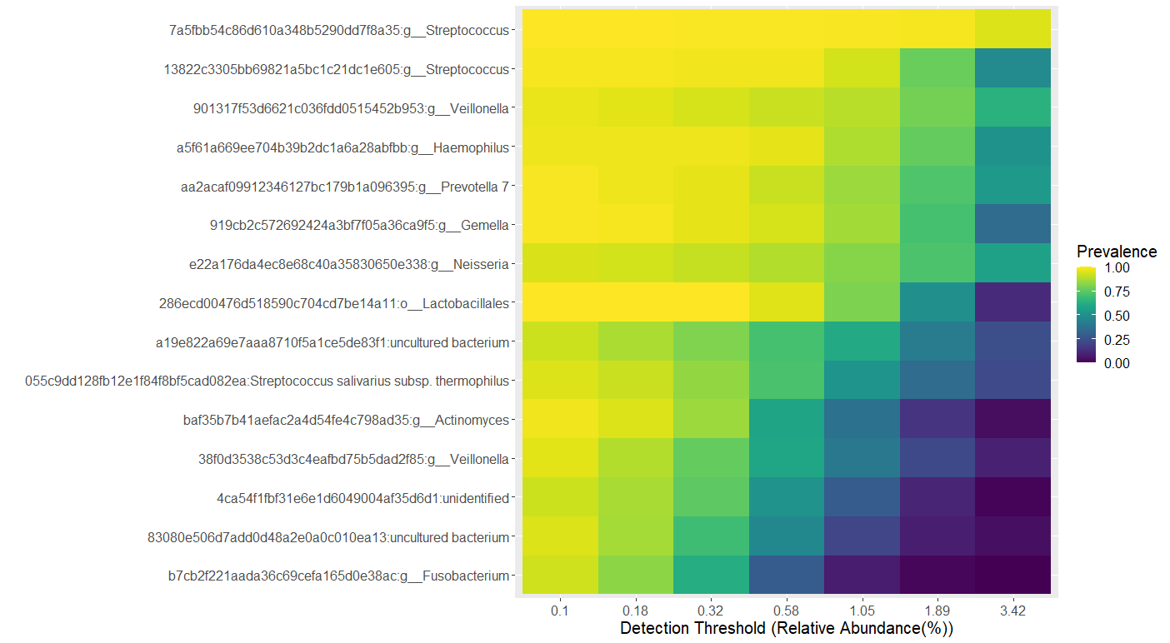
Supplementary Figure 1. Core oral microbiota constituents at the Genus level for at least 90% of the samples at 0.1% relative abundance detection threshold.

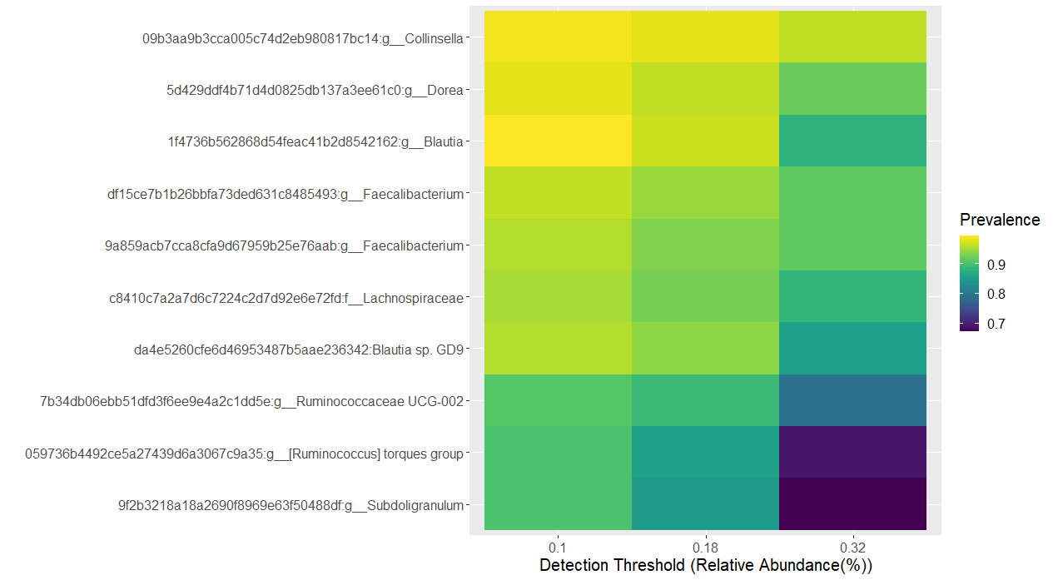
Supplementary Figure 2. Core gut microbiota constituents at the Genus level for at least 90% of the samples at 0.1% relative abundance detection threshold.

Supplementary Table 1. Pairwise comparison of OA communities reveal differentially abundant saliva bacteria genera using ALDEX2 (BH-corrected p-value <0.01 and effect size >1 or <-1).
 | Genus | Median clr of A# | Median clr of B# | effect | we.eBH | wi.eBH
Jehai vs Temuan | Campylobacter* | 2.16763122 | 4.131676404 | 1.407222 | 1.77E-10 | 5.61E-13
Jehai vs Temuan | Corynebacterium* | -0.500066048 | 2.653015978 | 1.286858 | 0.000525 | 3.63E-10
Jehai vs Temuan | Actinomyces* | 2.778093294 | 5.645405564 | 1.105451 | 9.47E-10 | 2.54E-10
Jehai vs Temuan | Prevotella* | 3.910704099 | 5.512669108 | 1.06383 | 5.24E-09 | 2.01E-10
Jehai vs Temuan | Mogibacterium | -5.93226897 | -0.618324232 | 1.010736 | 1.50E-06 | 3.47E-09
Jehai vs Temuan | Porphyromonadaceae uncultured* | -1.694333002 | -7.338729607 | -1.38314 | 3.24E-08 | 3.04E-11
Jehai vs Temuan | Prevotella 2* | 0.33947362 | -7.294457009 | -2.08066 | 8.12E-11 | 8.15E-14
Jehai vs Temuan | Candidatus Saccharibacteria bacterium UB2523 | -2.273947217 | -7.326312213 | -1.16308 | 2.29E-07 | 1.64E-09
Jehai vs Temuan | Lentimicrobiaceae unidentified | -1.467537763 | -7.350531936 | -1.09245 | 2.74E-07 | 1.64E-08
Jehai vs TemiarGM | Corynebacterium* | -0.504361837 | 2.88986973 | 1.728029 | 0.001233 | 1.23E-09
Jehai vs TemiarGM | Prevotella* | 3.911411123 | 5.512963911 | 1.385742 | 3.61E-09 | 7.06E-10
Jehai vs TemiarGM | Peptostreptococcus* | 0.316691682 | 2.144257044 | 1.036108 | 3.60E-06 | 5.01E-07
Jehai vs TemiarGM | Mogibacterium | -5.922086449 | -0.302276587 | 1.6123 | 6.58E-20 | 2.23E-11
Jehai vs TemiarGM | Porphyromonadaceae uncultured* | -1.691482449 | -8.547363103 | -1.88637 | 1.47E-07 | 3.78E-11
Jehai vs TemiarGM | Prevotella 2* | 0.342605791 | -7.813455872 | -2.35786 | 2.73E-08 | 1.75E-11
Jehai vs TemiarGM | Candidatus Saccharibacteria bacterium UB2523 | -2.277916993 | -8.54652133 | -1.61685 | 1.47E-07 | 2.65E-10
Jehai vs TemiarGM | SR1 (Absconditabacteria) (Phylum) | -1.493180901 | -8.564648551 | -1.20048 | 1.01E-06 | 3.32E-07
Jehai vs TemiarGM | Lentimicrobiaceae unidentified | -1.470012372 | -8.58279656 | -1.4566 | 2.63E-07 | 1.33E-08
Temiar vs Temuan | Campylobacter* | 2.139979433 | 4.138672914 | 1.314972 | 5.97E-12 | 1.20E-11
Temiar vs Temuan | Corynebacterium* | -0.72693244 | 2.652346306 | 1.306579 | 0.000431 | 1.33E-09
Temiar vs Temuan | Prevotella* | 3.350969384 | 5.50739596 | 1.268683 | 8.42E-12 | 6.87E-11
Temiar vs Temuan | Mogibacterium | -6.269334896 | -0.62160277 | 1.152272 | 3.07E-06 | 2.61E-09
Temiar vs Temuan | Porphyromonadaceae uncultured* | -1.10919176 | -7.325973728 | -1.56053 | 5.58E-09 | 1.59E-11
Temiar vs Temuan | Prevotella 2* | 0.147821669 | -7.320420306 | -1.84287 | 1.88E-09 | 4.18E-12
Temiar vs Temuan | Candidatus Saccharibacteria bacterium UB2523 | -1.527025681 | -7.308159352 | -1.10692 | 4.13E-07 | 2.11E-08
Temiar vs TemiarGM | Corynebacterium* | -0.728038296 | 2.890748377 | 1.73868 | 0.000585 | 3.11E-09
Temiar vs TemiarGM | Alloprevotella* | 2.238465264 | 4.835386013 | 1.448045 | 5.42E-13 | 2.86E-09
Temiar vs TemiarGM | Prevotella* | 3.347604267 | 5.510315022 | 1.506326 | 4.28E-12 | 9.01E-10
Temiar vs TemiarGM | Mogibacterium | -6.275329923 | -0.291390612 | 1.844286 | 1.02E-18 | 3.41E-11
Temiar vs TemiarGM | Porphyromonadaceae uncultured* | -1.104591349 | -8.514786221 | -2.12502 | 2.35E-08 | 7.97E-11
Temiar vs TemiarGM | Prevotella 2* | 0.148021047 | -7.787262937 | -2.03924 | 1.84E-08 | 2.13E-10
Temiar vs TemiarGM | Candidatus Saccharibacteria bacterium UB2523 | -1.527203395 | -8.510078529 | -1.5344 | 1.48E-07 | 6.36E-09
*A meaning the former of the pair, B being the later of the pair
*Bacteria genera identified in negative controls at <1.5% relative abundance

Supplementary Table 2. Pairwise comparison of OA communities reveal differentially abundant gut bacteria genera using ALDEX2 (BH-corrected p-value <0.01 and effect size >1 or <-1).
Group | Genus | Median clr of A# | Median clr of B# | effect | we.eBH | wi.eBH
Jehai vs Temuan | Sutterella | -0.882 | 5.690 | 1.101 | 5.86E-07 | 2.56E-08
Jehai vs Temuan | Odoribacter | -4.504 | 3.306 | 1.372 | 1.42E-08 | 6.29E-10
Jehai vs Temuan | Blautia* | 5.807 | 7.723 | 1.047 | 1.20E-07 | 1.73E-09
Jehai vs Temuan | Lachnoclostridium | 1.300 | 4.531 | 1.070 | 0.001156 | 4.96E-08
Jehai vs Temuan | Parabacteroides | -2.827 | 5.941 | 1.759 | 2.11E-18 | 4.48E-13
Jehai vs Temuan | Bacteroides | 2.216 | 7.811 | 1.472 | 6.93E-11 | 5.03E-11
Jehai vs Temuan | Ruminococcaceae UCG-013 | -5.103 | 2.323 | 1.149 | 2.87E-07 | 2.83E-08
Jehai vs Temuan | Prevotella 2* | 5.682 | -5.453 | -2.888 | 1.10E-13 | 4.75E-13
Jehai vs Temuan | Prevotella 9* | 8.082 | -0.465 | -2.145 | 2.78E-11 | 4.73E-13
Jehai vs Temuan | Lachnospiraceae ND3007 group* | 1.038 | -5.423 | -1.601 | 6.97E-09 | 4.59E-11
Jehai vs Temuan | Solobacterium* | 2.290 | -5.187 | -1.254 | 1.27E-07 | 5.50E-08
Jehai vs Temuan | uncultured Porphyromonadaceae bacterium* | 3.464 | -5.590 | -1.219 | 9.55E-09 | 2.12E-07
Jehai vs TemiarGM | Parabacteroides | -2.771 | 2.942 | 1.113 | 1.22E-05 | 1.54E-07
Jehai vs TemiarGM | Bacteroides | 2.282 | 5.610 | 1.106 | 1.39E-06 | 1.68E-07
Jehai vs TemiarGM | Lachnospiraceae ND3007 group | 1.112 | -6.070 | -2.095 | 2.66E-07 | 1.40E-10
Jehai vs TemiarGM | Prevotella 9* | 8.154 | 0.990 | -2.319 | 1.08E-07 | 1.58E-10
Jehai vs TemiarGM | Prevotella 2* | 5.754 | -1.296 | -1.499 | 7.77E-07 | 9.44E-10
Jehai vs TemiarGM | Solobacterium | 2.354 | -4.849 | -1.309 | 1.15E-06 | 1.97E-07
Temiar vs TemiarGM | Coprococcus 3 | 1.544 | 4.104 | 1.065 | 1.87E-06 | 1.53E-06
Temiar vs TemiarGM | Lachnospiraceae ND3007 group* | 1.122 | -6.027 | -2.105 | 1.35E-07 | 3.42E-10
Temiar vs TemiarGM | Prevotella 9* | 8.961 | 0.996 | -2.423 | 1.87E-08 | 3.20E-10
Temiar vs TemiarGM | Prevotella 2* | 6.641 | -1.341 | -1.575 | 1.85E-07 | 1.27E-09
Temiar vs TemiarGM | Solobacterium* | 1.030 | -4.877 | -1.008 | 4.93E-05 | 1.43E-05
Temiar vs Temuan | Odoribacter | -3.780 | 3.375 | 1.162 | 8.87E-08 | 2.52E-08
Temiar vs Temuan | Blautia* | 5.582 | 7.776 | 1.048 | 5.80E-08 | 1.12E-08
Temiar vs Temuan | Parabacteroides | -0.137 | 6.008 | 1.243 | 9.39E-12 | 1.85E-10
Temiar vs Temuan | Bacteroides | 3.350 | 7.864 | 1.060 | 7.17E-08 | 3.06E-08
Temiar vs Temuan | Ruminococcaceae UCG-013 | -5.166 | 2.394 | 1.215 | 3.69E-08 | 1.84E-08
Temiar vs Temuan | Lachnospiraceae ND3007 group* | 1.123 | -5.318 | -1.680 | 4.37E-09 | 1.75E-10
Temiar vs Temuan | Prevotella 9* | 8.961 | -0.389 | -2.252 | 5.30E-12 | 2.91E-12
Temiar vs Temuan | Prevotella 2* | 6.641 | -5.357 | -2.816 | 1.98E-14 | 4.50E-12
Obese vs Overweight | Prevotella 9* | 1.943 | 8.840 | 1.162 | 4.53E-11 | 2.52E-09
Obese vs Overweight | Prevotella 2* | -3.039 | 6.598 | 1.133 | 3.30E-10 | 3.24E-09
#A is the former and B is the later in pairwise comparison
*Bacteria genera were identified in negative controls. Prevotella 9 at 6.4%, the rest <2% relative abundance

Quality control
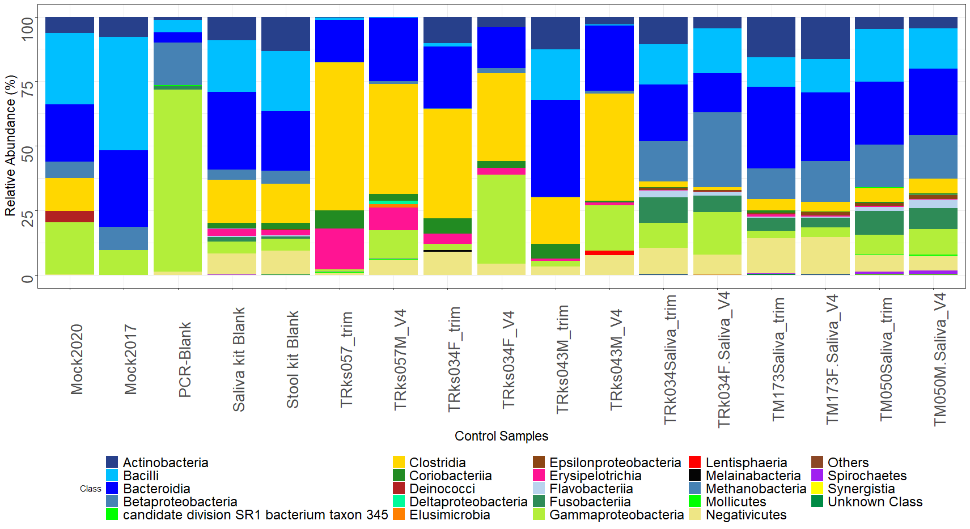
Supplementary Figure 3. Microbiota controls taxonomy bar plot

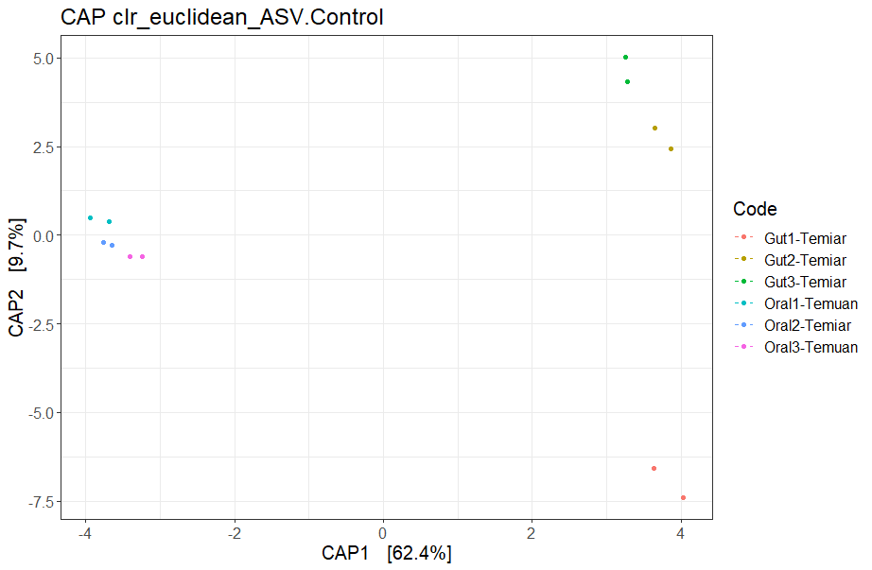
Oral
Supplementary Figure 4. Each colour pair indicates the same sample, one sequenced on V4 and another on V3-V4 trimmed to V4. Ordination plot shows that the same samples analysed on the V4 region still cluster together despite difference in extraction method and sequencing platform.

